CI328 – Internet Game Design & Development

UNIVERSITY OF BRIGHTON | SN: 17806554

Assignement 1

John Vos

2020

Table of Contents

Game Summary: 2

Game Story: 2

Objectives: 2

Rules: 2

Gameplay: 2

These stats are as follows: 2

Storyboard: 3

Greeting screen: 3

Heroes: 3

Fight screen pt.1: 4

Fight screen pt.2: 5

Game feedback messages: 6

Attack: 6

Defence: 6

Winning message: 6

Losing message: 6

Implementation Specification: 7

Game organisation: 7

Data structure: 7

Index page: 7

Game manager JS: 7

Player page JS: 7

Enemy page JS: 7

Algorithms: 7

Index page: 7

Game manager JS: 8

Player page JS: 8

Enemy page JS: 8

Deliverables: 8

Critical Review: 9

Development: 9

Improvements: 9

Menu: 9

Only able to attack: 9

Unable to fight more than one opponent: 9

Assets: 10

Hero / Player characters: 10

Assassin: 10

Hunter: 10

Mage: 11

Rogue: 11

Warrior: 12

Enemy characters: 12

Goblin: 12

Orc: 13

Troll: 13

# Game Summary:

## Game Story:

The main story of the game is you are an adventure who has just woken up with no memory, you must venture out to find out what happened. Your first task is picking a character.

## Objectives:

Your objective is to make your way through enemies.

## Rules:

The rules are simple, a player picks a hero that has set stats, once the player has picked their hero they must search for a random enemy and fight the enemy to the death.

## Gameplay:

Talk about characters different traits / stats.

Each character has unique stats and these stats determine the outcome of battles, for example, a faster character will get to attack first due to their speed but will deal less damage than a slower character as slower characters deal more damage.

### These stats are as follows:

|  |  |  |  |  |  |  |  |
| --- | --- | --- | --- | --- | --- | --- | --- |
|  | Character: | health: | mana: | strength: | agility: | speed: | total: |
| Hero: | assassin | 150 | 50 | 150 | 300 | 350 | 1000 |
| hunter | 150 | 100 | 200 | 300 | 250 | 1000 |
| mage | 150 | 350 | 100 | 200 | 200 | 1000 |
| rogue | 200 | 50 | 250 | 250 | 250 | 1000 |
| warrior | 550 | 0 | 350 | 50 | 50 | 1000 |
|  |  | | | | | | |
| Enemy: | goblin | 200 | 150 | 150 | 250 | 250 | 1000 |
| orc | 200 | 200 | 200 | 200 | 200 | 1000 |
| troll | 450 | 50 | 400 | 50 | 50 | 1000 |

# Storyboard:

## Greeting screen:

This is the screen the player is first greeted on when they launch the game, and where they are prompted to pick a class.

## Heroes:

This screen shows all the playable heroes and a brief description of the class to give a player an idea of what traits these characters have and so they can pick a class that best represents their play style.

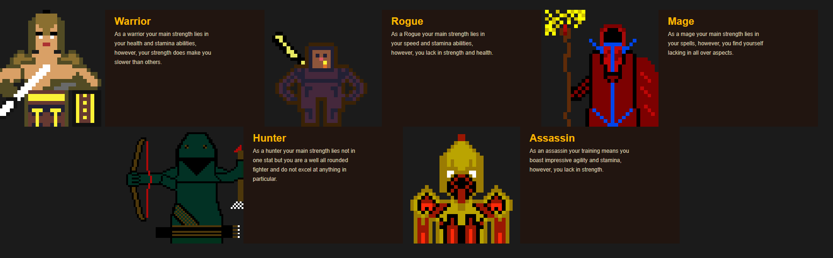

## Fight screen pt.1:

This is the screen the player sees once they have selected their chosen character and they are prompted to search for an enemy to fight.

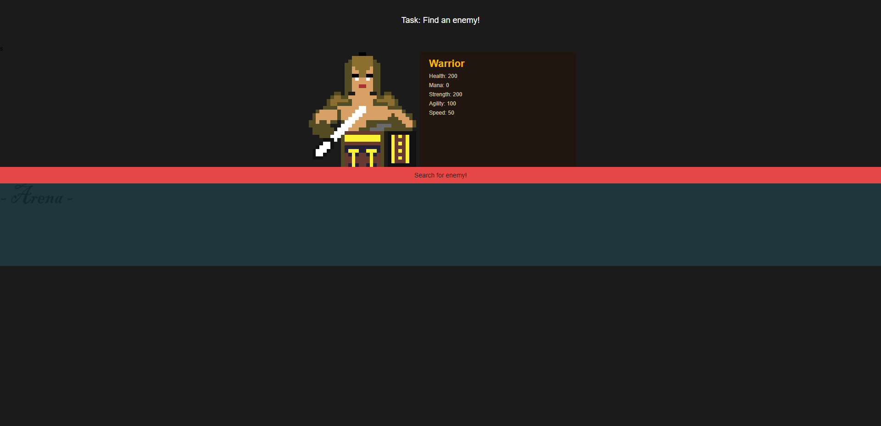

## Fight screen pt.2:

This screen is what the player will see once they have found an enemy to fight and they can begin attacking.

## Game feedback messages:

|  |  |
| --- | --- |
|  |  |
| Winning message: |  |

# Implementation Specification:

## Game organisation:

The game folder is structured as follows:

* /assets
  + /avatar-enemies
  + /goblin
  + /orc
  + /troll
  + /avatar-player
    - /assassin
    - /hunter
    - /mage
    - /rogue
    - /warrior
  + /arena
  + style.css
* /js
  + /enemy
  + /gamemanger
  + /player
* /libs
  + /jquery.min
  + /phaser
  + /phaser. In
* index

## Data structure:

### Index page:

The general code is structured as follows; the main *index page* is the first page the player sees where they are greeted with a title, a small snippet of text and the characters they can chose from. The index page loads all scripts and JS files as well as setting up the page players see.

### Game manager JS:

The game manager page is the biggest component of the project as this JS file contains all the major functions and properties the game relies on.

### Player page JS:

The enemy page declares the player type.

### Enemy page JS:

The enemy page declares the enemy type.

## Algorithms:

### Index page:

Besides previously mentioned script loading and general information for the player, the index page has a built in onclick function which is used for when the character picks the character, they want to play it will move the game to the next scene based upon which character they have chosen.

### Game manager JS:

A key feature of game manager is the player and enemy function that sets up the heroes and enemies and their stats, i.e. health, mana, strength, agility, speed as each character has unique stats. Moreover, a random number generator function is used to randomly select which enemy type is chosen using a *math.floor* function.

### Player page JS:

The player script allocates the players stats that are displayed on screen (*index*) and then manipulates the stats displayed depending on damage taken and dealt. The amount of damage dealt is determined in the *gamemanager* script and who attacks first and for how much is decided here too. Who attacks first is dependent the characters speed, so a faster character will attack first, however, faster characters tend do deal lower damage than slower character for game balancing.

### Enemy page JS:

The enemy script declares the enemy.

## Deliverables:

|  |  |  |
| --- | --- | --- |
| Task: | Date due by: | Difficulty: |
| Hero assets | 08/10/2019 | Moderate |
| Enemy assets | 15/11/2019 | Moderate |
| Index page | 22/11/2019 | Moderate |
| Hero script | 06/12/2019 | High |
| Enemy script | 10/01/2020 | High |
| game manager script | 24/01/2020 | Very High |
| Submission | 27/01/2020 | N/A |

# Critical Review:

## Development:

The assets and transitions are smooth are user friendly.

## Improvements:

### Menu:

The game could would really do with a menu where players can choose a difficulty, sound, credits, etc… I tried developing them and had some moderate success, but not enough for them to be fully implemented into the game.

### Only able to attack:

The player can only attack, no option to defend or dodge or run away.

### Unable to fight more than one opponent:

Once an opponent is defeated the player can only refresh and restart, there is no progress or score tracking. A score system was developed but was not functioning well enough to be implemented in this cycle.

# Assets:

## Hero / Player characters:

### Assassin:

The assassin is a hero character that favours stealth, agility, and speed over brute force.

### Hunter:

The hunter is a class that is simply trying to defend their land and way of living.

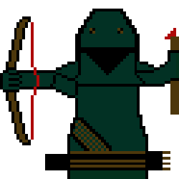

### Mage:

The mage is a wizard that comes from a magic school in a land far far away simply trying to get on with their travels but cannot let the innocent simply suffer.

### Rogue:

The rogue is a person only interested in money and chaos.

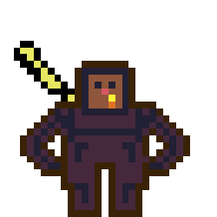

### Warrior:

The warrior is out for glory and fame, will slay any and all creatures he comes across using brute force and strength.

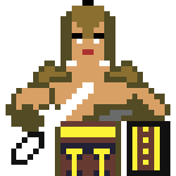

## Enemy characters:

### Goblin:

Globlins are agile, fast, sneaky creatures simply out for blood

### Orc:

Orcs are the middle ground between the goblins speed and the brutality of a troll.

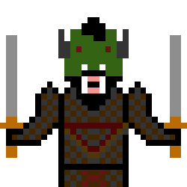

### Troll:

Trolls are creatures not to be crossed simply, they will crush and tear apart any poor soul that comes across them.

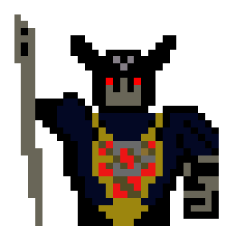

# References

Anon., n.d. *Piskel Asset.* [Online]   
Available at: https://www.piskelapp.com/  
[Accessed 12 - 01 2019 - 2020].

Anon., n.d. *W3Schools.* [Online]   
Available at: https://www.w3schools.com/graphics/game_canvas.asp  
[Accessed 12 - 01 2019 - 2020].

Davey, R., 2018. *Phaser.io.* [Online]   
Available at: https://phaser.io/tutorials/making-your-first-phaser-3-game/part2  
[Accessed 12 - 01 2019 - 2020].

Gwens, 2017. *GitHub.* [Online]   
Available at: https://github.com/Apress/pro-html5-games   
[Accessed 12 - 01 2019 - 2020].

Manai, W., 2018. *Dev Dojo.* [Online]   
Available at: https://devdojo.com/tutorials/create-your-first-html5-game-with-phaserjs  
[Accessed 12 - 01 2019 - 2020].

Schardon, L., 2019. *Phaser Tutorials.* [Online]   
Available at: https://phasertutorials.com/web-class-learn-rpg-mechanics-in-phaser/  
[Accessed 12 - 01 2019 - 2020].

Westover, S., 2019. *Phaser Tutorials.* [Online]   
Available at: https://phasertutorials.com/creating-a-phaser-3-template-part-1/  
[Accessed 12 - 01 2019 - 2020].

Westover, S., 2019. *Phaser Tutorials.* [Online]   
Available at: https://phasertutorials.com/phaser-leaderboard-with-user-authentication-using-node-express-mongodb-part-5/  
[Accessed 12 - 01 2019 - 2020].